What is Eco-Art?

Leila Christine Nadir
Wellesley College
lcnadir@gmail.edu

Ice, Sticks, Rocks
Ice, sticks, rocks: these need not be the media of eco-art. The Greek etymological origins of “eco-art” are oikos (house or dwelling) + art (to fit together). To fit together a home—and where else do we make our homes but in cities, suburbs, countrysides, on highways and subway trains, online and networked amidst wireless connections and seemingly isolated on hikes in national parks? For philosopher Félix Guattari, the term “eco-art” recalled the effort to make social, environmental, and psychological ecosystems “habitable by a human project,” to make ourselves and others (rather than capital) at home in the world. “Ecology must stop being associated with the image of a small nature-loving minority,” he wrote. “It is not only species that are becoming extinct but also words, phrases, and gestures” (Guattari, 2000, p. 35 & p. 29).

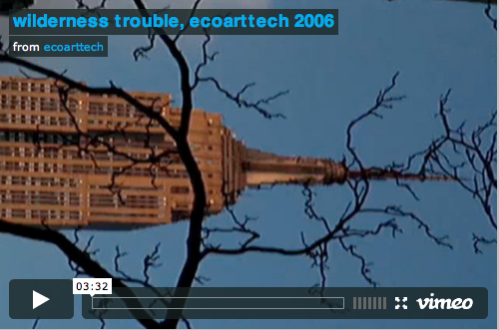 Wilderness Trouble—digital video (ecoarttech, 2006)

The Figure of Home-Making
The figure of home-making, or “eco-art,” in a rapidly transforming world appears repeatedly in fiction and non-fiction across the past century. Sometimes nostalgically, as in Willa Cather’s 1925 novel, The Professor’s House, in which domesticity becomes a way to maintain a sense of place amidst global markets, rampant consumerism, and upward mobility: Cather’s professor refuses to give up his rundown, too-small rented house when he makes an attractive sum of money (Cather, 1990). Other times, home-making leaves the literal “house” and becomes an imaginative, conceptual act, as in Marshall Berman’s (1988) definition of modernism as “any attempt by modern men and women to become subjects as well as objects of modernization, to get a grip on the modern world and make themselves at home . . .” (p. 5).

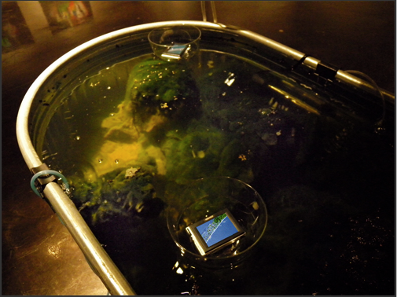
Untitled Algae for Portable Media Players—algae, microscopy, installation with digital video (ecoarttech, 2010)

Eco-Art Can Hold onto What is Lost in Mobile Non-Location
Eco-art can hold onto what is lost in mobile non-location; it can entail staying put. Or eco-art can create a “habitable” space within dizzyingly new experiences, a space hospitable to human-animal creativity. Or perhaps, always, eco-art performs both at the same time. Eco-art is dis-placed continuity and continuous dis-location. It is responsive resistance and resistant response. It is homelessness, or restlessness, at home with itself. It is neither truly nostalgic, nor inherently progressive. When Arthur and Marilouise Kroker define “critical digital studies,” they articulate this sentiment without reference to homemaking or eco-art: “There is a desperate requirement to do something that is as ancient as it is futurist: to find the ‘words’ by which to make familiar to our senses the new home of digital technologies within which we have staked our identities” (Kroker & Kroker, 2008, pp. 7-8).

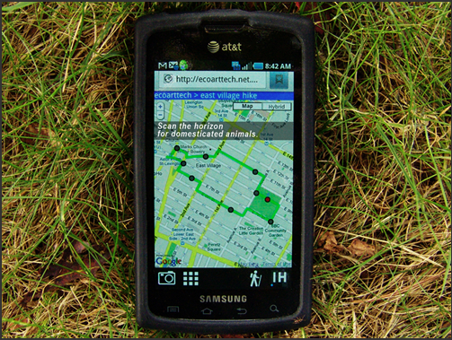
Indeterminate Hikes—Custom Android app for urban hiking (ecoarttech, 2010)

Eco-Aesthetics are Also Ethics
Eco-aesthetics are also ethics—ethics not as moral code but ethics as many French philosophers have defined it, as responsiveness to otherness. For Foucault, ethics and art blurred, each involving the invention of new styles “other” to what we have thus far known: “We must think that what exists is far from filling all possible spaces. To make a truly unavoidable challenge of the question: What can be played?” (Foucault, 1997, p. 140). In that interview, Foucault was talking about sexual ecology. In Three Ecologies, Guattari was writing about the ethico-aesthetics of environmental, social, mental, and media ecologies. From Cather’s romantic modernism to the Krokers’ digital studies, whether we work with leaves or letters or binary code, are we not searching for ways to dwell in these intertwining networks, to update or reinvent our homemaking and culture-making skills? This is why the art and theory collaborative I co-founded with artist Cary Peppermint, ecoarttech, believes the environmental movement needs eco-art.

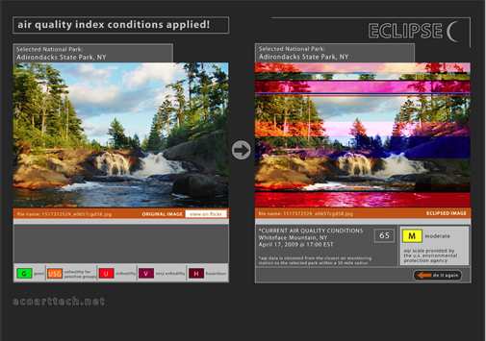
Eclipse—dynamic data-driven Web app (ecoarttech, 2010)

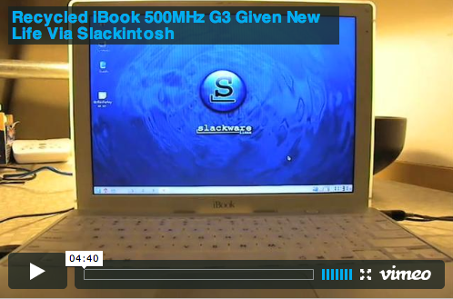

Recycled iBook 500MHz G3 Given New Life via Slackintosh—
recycled iBook, slackintosh open source operating system (ecoarttech, 2010)

References

Berman, M. (1988). All is solid that melts into air. New York: Viking Penguin.

Cather, W. (1990). The professor’s house. New York: Random House. (Original work published in 1925).

Foucault, M. (1997). Friendship as a way of life. In P. Rabinow (Ed.), Ethics, subjectivity, and truth (pp. 135-140). New York: New Press.

Guattari, F. (2000). The three ecologies (I. Pindar & P. Sutton, Trans.). London: Athlone Press. (Original work published in 1989).

Kroker, A., & Kroker, M. (2008). Critical digital studies: An introduction. In Kroker & Kroker (Eds.), Critical digital studies: A reader (pp. 1-21). Toronto: University of Toronto Press.

